Model Calibration HW: Due Thursday with your chaos problem

Download the “nitrification_ode_hw_canvas_2017.m”
Follow the instructions at the bottom of this m-file to generate a function file and calibrate the ODE model by reducing the error calculated between the observed data and the model. Only modify coefficients on lines 12-14 and 20-23!

In summary from lecture:

- Ammonia oxidizing bacteria (AOB)

NH₃ + 1.5 O₂ → NO₂⁻ + H₂O + H⁺
- Nitrite oxidizing bacteria (NOB)
NO₂⁻ + 0.5 O₂ → NO₃⁻

Model equations

Growth of ammonia oxidization bacteria (AOB):
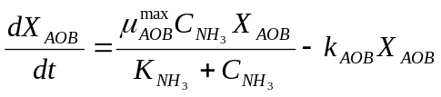

Growth of nitrite oxidization bacteria (NOB):
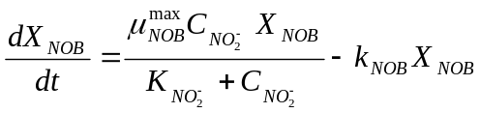

Concentration of total ammonia (NH₃):
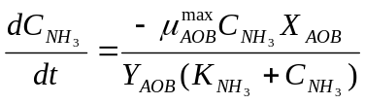

Concentration of nitrite (NO₂⁻):
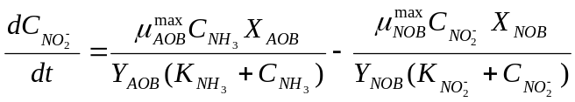

Concentration of nitrate (NO₃⁻):
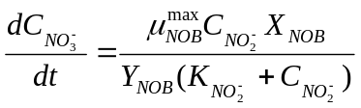

Unknowns
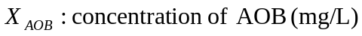
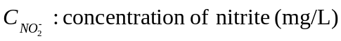
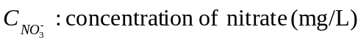

Model parameters
